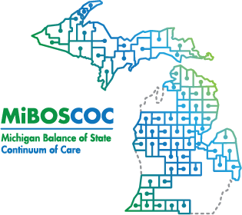 | Michigan Balance of State Continuum of Care  Governance Council Meeting  December 14, 2023  10:00 am - 12:00 p.m.  Link: https://us02web.zoom.us/meeting/register/tZcvcOmppjgrGdwHIqdGJDJFcPL_HLZ9AUgV
Meeting Agenda
10:00-10:01 | Welcome and Introduction
10:01-10:02 | Review/Approve Agenda (action item)
10:02-10:05 | Review/Approve November Meeting Minutes (action item)
Presentations and Discussions
10:05-10:35 | 211 Update - Tina Allen
10:35-10:50 | State Partner Update- Emergency Shelter Program - Takisha Jones
Committee Updates
10:50-10:55 | Coordinated Entry – Sarah Hughes (Ashley Halladay-Schmandt- Staff)
10:55-11:00 | Performance and Outcomes – Tina Allen (Jayce Ashwill- Staff)
11:00-11:10 | Funding Committee – Lori Pieri
11:10-11:15 | Membership and Equity – Katrina Pelfrey
11:15-11:20 | Homeless Expertise Leading Programming (HELP) Committee – Susan Williams
11:20-11:25 | Youth Action Board (YAB) – TBD
11:25-11:40 | Vulnerable Populations  - Youth – James Perlaki  - DV – Erin Viau  - Veterans – Carly Huffman or Katie Graham
11:40-11:45 | Coordinator Update
11:45-11:55 | HMIS Administrator Update
11:55-12:00 | Public Comment/Announcements
Adjourn
Next MIBOSCOC Governance Council Meeting
Thursday January 11, 2023
10AM - 12PM

