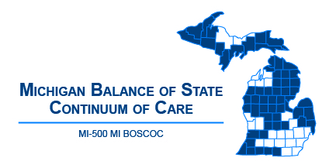 | Michigan Balance of State Continuum of Care  Governance Council Meeting  November 8, 2018  10:00 am - 12:00 p.m.  Webinar:  https://attendee.gotowebinar.com/register/129280967506122753
Meeting Agenda
10:00-10:05 | Welcome and Introduction
10:05-10:10 | Review/Approve Agenda (action item)
10:10-10:15 | Review/Approve October 17 Meeting Minutes (action item)
10:15-10:45  (30 minute  presentation and Q & A) | - 2019 Point In Time Count – Christina Soulard, Coordinator
Committee Updates
10:45-10:55 | Coordinated Entry – Ashley Halladay-Schmandt
10:55-11:05 | Finance – Denise Cornelius
11:05-11:15 | Performance and Outcomes – Alice Stone  - Review/Approve Drafted Policy and Procedures (action item)
11:15-11:25 | Membership and Nominating – Christa Jerome
11:25-11:35 | Contractual Oversight – Denise Cornelius
11:35-11:45 | HUD CoC Application and Evaluation – Lori Pieri
11:45-11:55 | Vulnerable Populations – Bill Jessup
11:55-12:00 | Public Comment/Announcements
Adjourn
Next MI BOSCOC Governance Council Meeting
Thursday, December 13, 2018
10am to 12pm

