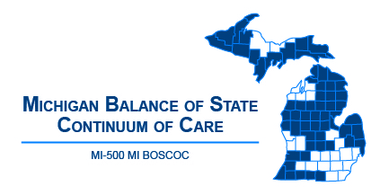 | Michigan Balance of State Continuum of Care  Governance Council Meeting  August 9, 2018  10:00 am - 12:00 p.m.  Webinar:  https://attendee.gotowebinar.com/register/129280967506122753
Meeting Agenda
10:00-10:05 | Welcome and Introduction
10:05-10:10 | Review/Approve Agenda (action item)
10:10-10:15 | Review/Approve July 12 Meeting Minutes (action item)
10:15-10:40  (25 minute  presentation and Q & A) | - Racial Disparity: Comparing Census and HMIS Data – Christina Soulard, Coordinator
Committee Updates
10:40-10:50 | Coordinated Entry – Ashley Halladay-Schmandt  - Updated Coordinated Entry Policy – Equal Access HUD Reference  - OrgCode Technical Assistance Update
10:50-11:00 | Finance – Denise Dunn  - Review/Approve FY17 Planning Grant Budget (action item)
11:00-11:15 | HMIS and Performance and Outcomes – Alice Stone
11:15-11:25 | Membership and Ad-Hoc: Nominations – Christa Jerome
11:3-11:35 | Monitoring – Denise Dunn  - Review/Approve MCAH and BoS CoC MOU for FY17 Planning Grant activities (action item)
11:35-11:45 | Project Evaluation – Lori Pieri  - Review/Approve Reallocation Policy (action item)  - Review/Approve FY18 HUD CoC Project Ranking (action item)
11:45-11:55 | Vulnerable Populations – Bill Jessup
11:55-12:00 | Public Comment/Announcements
Adjourn
Next MI BOSCOC Governance Council Meeting
Thursday, September 13, 2018
10-12pm

